**An ArtfulScribe commissioned Equality Diversity and Inclusion Report on**

**Ethnic Diversity in the New Forest, what ethnic minorities want to see from Arts and Culture in the New Forest, and an overview of relevant EDI work (successes and challenges) by New Forest organisations.**

February 2025

Authored by Amy Hardingson, research lead

**Aims of the research project**

The aims of this research project were to gather information on the ethnic diversity demographics in the New Forest, to identify target groups and individuals open to interaction, to seek out and make new connections, to gather viewpoints on current arts engagements, and to gather ideas that could enhance the arts and literature offer in the New Forest for ethnic minority individuals.

**About the researcher, bias and research limitations**

I am a local British Burmese author and poet commissioned by ArtfulScribe to lead and complete this research project. I grew up in Southampton and have lived in the New Forest town of Totton for 9 years. I was a Town Councillor in Totton and Eling from 2019-2023. During my time as a Councillor, I was also an advisory board member for Hanger Farm Arts Centre, and the Totton Festival of Drama, and was project manager for the Totton Community Rail Mural Project.

While local knowledge and lived experience of being an ethnic minority living in the New Forest are helpful to achieving some of the aims of this research project, it is also important to acknowledge that every researcher brings their own bias. I acknowledge having an existing bias towards Totton and the eastern side of the New Forest (being more familiar with those areas at the start of this project), as well as towards the Asian community. To the best of my ability, I have worked to ensure that subconscious bias is minimized in the delivery of this project, and that own voices are consulted as much as possible.

**Research methods**

An online questionnaire was created using Culture Counts (accessed via Arts Council England’s Impact to Insight Toolkit). Two focus groups were also planned, one in-person held at Fluid Motion Creative Hub in Totton, and one online. The questionnaire and focus groups were advertised in a leaflet which was distributed across the New Forest. A number of key contacts were also emailed directly, and a number of in-depth conversations and one-on-one interviews conducted over email and in-person.

Additional to the above, an overview of available statistics and baseline data available in existing reports was conducted (including 2021 census data). However, it is important to note that I am a writer and not a statistician, and any errors in the handling of this data are my own. References are included for those who wish to look into the raw figures themselves.

**Executive Summary**

**Demographics key findings** *details on pages 4-11*

* There are more than 10,000 ethnic minority individuals living in the New Forest.
* The New Forest has a concentration of employment in the tourism, hospitality and care industries (all of which have a proportionately more ethnically diverse workforce).
* Ethnic minorities are widely distributed across the entire New Forest district (including rural areas), with nearly every village and town having similar percentages of Asian, Black, GRT, and European populations.
* There is a significant Black population in Marchwood and the waterside, with the Fijian and Ghanaian communities being particularly prominent and active.
* There is a significant, concentrated ESEA population in central New Milton.
* Asians are the largest non-white ethnic group in the New Forest, representing about ¼ of the total ethnic minority population of the New Forest and more than half of the POC in the New Forest.
* The Mixed Race/Mixed Heritage population represents close to ¼ of the ethnic minority population with an almost even split between ‘Mixed with Asian’ and ‘Mixed with Black’.

**Existing cultural assets key findings** *details on pages 19 and 22-23*

* African Activities have been doing significant work in the district for 20 years.
* The Indian War Memorial at Barton-on-Sea has a group dedicated to preserving the obelisk and telling the story of the Indian army hospitals in the New Forest during the First World War.
* Evidence of high interest and engagement in Gypsy projects. Romany Gypsies are both significant to the history and culture of the New Forest, and the New Forest is significant to the history and heritage of English Gypsies.

**Key findings from arts organisations** *details on page 22*

* Organisations have low awareness of ethnic minority demographics in the New Forest.
* Organisations are unsure where to go for support/contacts.
* There’s been a recent increase in projects happening, but awareness is low.

**Key Findings from focus groups, survey and interviews** *details on pages 12-17*

* Trust has to be built. Investment for relationship building & safe spaces is key.
* Informal cross-cultural events was the most popular idea from the survey.
* People have difficulties in finding out what is going on.
* Desire for more opportunities for ethnic minority individuals to meet and build community locally.
* Desire for antiracism support and signposting.
* Desire for panels/workshops dedicated to diversity at existing New Forest events/festivals.

**Contents**

**Ethnic Diversity in the New Forest 4**

Population of the New Forest (background) 4

Ethnic Diversity in the New Forest (census data) 5

Ethnic group distribution across the rural New Forest 7

Including researcher observations and anecdotal evidence 7

Asian population in the New Forest 7

Black population in the New Forest 9

European population in the New Forest 9

Gypsy, Roma, Traveller population in the New Forest 10

Other ethnic groups in the New Forest 11

**What do Ethnic Minorities want from their local Arts and Culture? 12**

Results from the focus groups 12

Results from the online questionnaire 14

Summary of relevant one-to-one conversations 17

**African Activities – Highlight 19**

**How are New Forest organisations engaging in Ethnic Diversity work? 22**

Summary of conversations with New Forest organisations 22

Previous projects and points of interest 23

**Preventing racism, tokenism and cultural appropriation in your work** 25

**Conclusions and recommendations 27**

**References 30**

**List of useful resources 32**

**Appendix 34**

Census data 34

Focus Group evidence 35

Online questionnaire results 36

Ethnic Diversity in the New Forest - Overview

**Population of the New Forest**

According to the 2021 census data, the total population of the New Forest is 175,800[1]. The New Forest district is considered a rural area, and it is the 10th least densely populated local authority in the South East, with just two people per football pitch of land.[2] The New Forest also has the joint second highest median age in the South East, with the average age being 51 years.[3] While often perceived as an affluent area, the average salary in the New Forest is £40.9k, below the national average of £45.8k[4], which likely reflects the fact that the New Forest is ‘an area of great inequality, with many people unable to live comfortably on their current income living alongside notable wealth.’[5] Another interesting point to note is that there is a concentration of employment sectors in the New Forest, with Care, Tourism and Marine industries being over-represented, while Knowledge Intensive industry is almost half of the national concentration (0.59 compared to 1.0).[6] The national park is a major tourist attraction, with an estimated 13.5million day visits a year (over 60% of which are visitors who live close to the national park).[7]

Of the 175,800 people living in the region, only approximately 34,000 of those live inside the National Park boundaries.[8] The population density in the New Forest is highest at the edges of the district, with Totton and Eling (28,657), Hythe and Dibden (20,172), Lymington and Pennington (15,832), Ringwood (14,624), Fawley (14,015) and New Milton (25,544) having 118,844 of the total residents in the district.[9] These are the areas where the majority of the infrastructure for the New Forest is, and also where the ethnic diversity is highest.

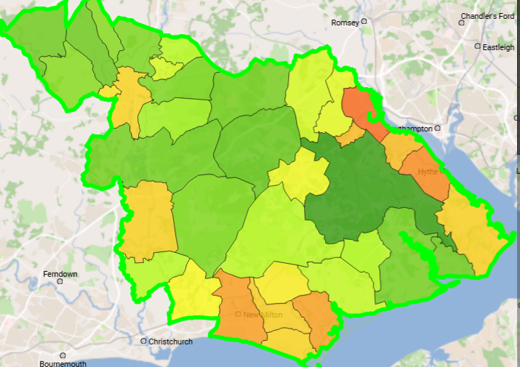Fig 1

**Ethnic diversity in the New Forest – census data**

According to the 2021 census data, 5,664 people living in the New Forest identifies with an ethnic group other than White. A further 5,827 list their country of birth as being in the EU or elsewhere in Europe.[10] And 604 people self-identified as Gypsy, Roma or Traveller.[11] It is also worth noting that these numbers captured from the census won’t capture people who work in the New Forest but live outside of the district. Ethnic minorities are also far more likely to not fill in a form like the census, whether due to language difficulties, time pressures, or un-ease around documenting personal data. When it comes to the Gypsy, Roma and Traveller communities in particular, low levels of ethnic group ascription in forms is well documented.[12]

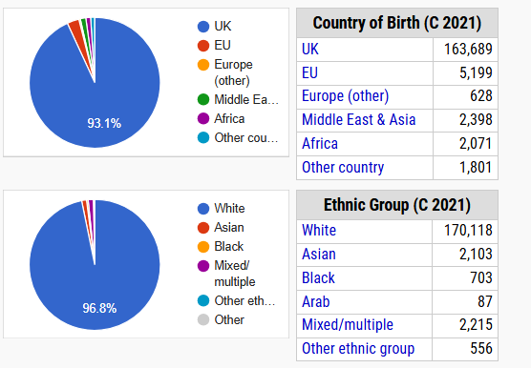Fig 2

One thing that we can quickly tell from the census data is that from the non-white ethnic groups Asian comes out as the largest ‘umbrella’ ethnic group, and that almost half of the non-white ethnic minority individuals identify as mixed-race or multiple heritage. When looking at the breakdowns of these statistics town by town, the same pattern tends to be followed across the New Forest with Asians and Mixed tending to be the largest groups with the percentages being largely similar.

One interesting exception to this pattern is Marchwood, with a notably higher non-white population, with Black being the largest group.

|  |  |  |  |  |
| --- | --- | --- | --- | --- |
|  | Non-white | Asian | Black | Mixed |
| Totton and Eling | 3.6% | 1.5% | 0.5% | 1.3% |
| Hythe and Dibden | 3% | 0.9% | 0.5% | 1.2% |
| Lymington and Pennington | 3.2% | 1.1% | 0.2% | 1.3% |
| New Milton | 4.2% | 2.1% | 0.3% | 1.4% |
| Ringwood | 3.1% | 0.9% | 0.3% | 1.4% |
| Fordingbridge | 1.9% | 0.7% | 0.3% | 0.8% |
| Fawley | 2.4% | 0.6% | 0.4% | 1% |
| Marchwood | 6.9% | 1.3% | 2.9% | 2.1% |

Table 1

**Deeper analysis**

I have also looked at the more detailed data available directly from the 2021 census, looking at the specific ethnic groups listed by census respondents across the New Forest broken down by electoral ward. The main trouble with this more detailed data is that when you download the data from Nomis (Official Census and Labour Market Statisticians)[13] a message is included that ‘[i]n order to protect against disclosure of personal information, records have been swapped between different geographic areas and counts perturbed by small amounts. Small counts at the lowest geographies will be most affected.’[14] Because we are looking at small counts across a rural area, the raw data cannot be securely relied upon. However, we can look at the numbers provided to look for trends and patterns in the data, and how this intersects with other information collected via this research.

**Ethnic group distribution across the rural New Forest**

One interesting thing that the census data by electoral ward shows us is the distribution of different ethnic groups across the region. While the ethnic diversity of the bigger New Forest towns is a bit higher, it is not as big an outlier from the rural New Forest as many might expect. The percentages you derive from the New Forest wide ethnicity data can be applied to nearly every New Forest electoral ward. Every area, without exception, has a Black, Asian, Eastern European, and Western European population. And only one New Forest ward recorded no Gypsy/Roma/Traveller identifying respondents[15], with again this ethnic group showing a very wide and even distribution across the district.

**Including researcher observations of visibility and other anecdotal evidence**

When distributing leaflets which advertised the online questionnaire and focus groups, I focused on high streets across the New Forest, delivering to takeaways, beauty salons, restaurants and any other small businesses with visible ethnic branding elements or staff that appeared to be likely members of ethnic minority groups. I recorded the names of the businesses that I delivered to, and tried to observe as much as I could about the visible ethnic culture of the high streets in New Milton, Lymington, Brockenhurst, Lyndhurst, Ashurst, Totton, Marchwood and Hythe.

Without any kind of self-identification from these businesses and the individuals working in them, this information is very much based on assumptions that I as the researcher was making. However, I do think that looking at these rough numbers is useful (especially when looked at in conjunction with some of the census data), even if there is a high margin for error in assumed ethnicity ascription. The diversity of a high street also has a large impact on how all New Forest residents think of their community, and has an impact on the overall identity of our towns and villages.

In the following analysis of the populations of different ethnic groups in the New Forest, I will be including these observations of my own, alongside anecdotal evidence collected in conversations with Parish Councillors and staff members of African Activities, who were incredibly helpful in providing useful leads, stories and information relevant to this research project.

**Asian population in the New Forest**

One of my key questions at the start of this project was whether the New Forest Asian population had more ESEA (East and South East Asian) or SA (South Asian) individuals. In terms of thinking about arts and cultural programming that is related to festivals, folklore or mythology (or even relevant food culture and cultural care) these are distinct groups within the very broad Asian diaspora category.

|  |  |
| --- | --- |
| **Asian Ethnic Groups top results (detailed census response)** | **New Forest Totals** |
| Indian | 577 |
| Chinese | 437 |
| Filipino | 320 |
| Bangladeshi | 173 |
| Thai | 151 |

Table 2

|  |  |
| --- | --- |
| **Broad Asian ethnic groups (my grouping)[16]** | **New Forest Totals** |
| ESEA | 1037 |
| South Asian | 947 |
| Mixed with Asian | 857 |

Table 3

This more or less even weighting, with a slight bias towards the ESEA community was also matched by the visible ethnic business data I collected. I recorded 32 ESEA businesses across the New Forest, and 27 South Asian businesses.

However, the picture looks different in our two largest towns; Totton and New Milton.

New Milton has a much larger ESEA population (295 ESEA vs 186 SA), with a particularly strong concentration of Chinese and Filipino respondents in the Milton electoral ward (over half the ESEA population of New Milton lives in this central area). New Milton’s visible ethnic businesses are also more significantly leaning towards ESEA (5 ESEA vs 3 SA). The Catholic Church in New Milton is a known hub for the Filipino community in particular[17]. There is also a longstanding Mahjong club at the New Milton Community Centre.[18]

Totton has a much larger South Asian population (249 SA vs 166 ESEA), but these populations are fairly evenly distributed across the wards of the town. Totton’s visible ethnic businesses lean slightly towards South Asian (15 SA vs 12 ESEA). Totton also has by far the most visible ethnic presence in the New Forest with close to half of the visibly ethnic businesses across the district being in Totton. In my observation, Totton’s high streets are also the places in the New Forest where you are most likely to hear several different languages as you walk along.

**Black population in the New Forest**

Across most of the New Forest, the Black population steadily holds at about 0.5% of the population of each ward. There is a slightly higher number of Black African ethnic identities (393), compared to Caribbean identities (315).

|  |  |
| --- | --- |
| **Black Ethnic Groups top results (detailed census response)** | **New Forest Totals** |
| Black African (unspecified) | 228 |
| Black Caribbean (unspecified) | 164 |
| Black British | 82 |
| Ghanaian | 26 |
| Nigerian | 35 |
| Polynesian/Micronesian/Melanesian | 105 |
| Mixed with Black | 880 |

Table 4

However, as we’ve already noted, the story is very different in Marchwood. Here the Black population is much higher, almost 3% of the population, which rises to 4% when including the Black mixed-race groups.

Marchwood’s different demographics to the rest of the New Forest are likely caused by the Marchwood Military Port, and their personnel which includes a significant proportion of staff from across the commonwealth territories.[19]

The Fijian community is particularly strong in Marchwood and the Waterside, as noted on the Marchwood Junior school website “Fijian culture is a strong influence on the school community and is celebrated frequently in events such as Love of Fiji day and the Fijian Rugby Book Project”[20]

**European population in the New Forest**

|  |  |
| --- | --- |
| **European Ethnic Groups top results (detailed census response)** | **New Forest Totals** |
| Irish | 835 |
| Polish | 657 |
| Romanian | 247 |
| German | 158 |
| Spanish | 157 |
| French | 150 |
| Italian | 142 |
| Hungarian | 105 |

Table 5

The biggest non-UK Ethnic identity in the New Forest is Irish, at 835 census respondents. There are slightly higher concentrations of Irish identifying individuals in Lymington and Fordingbridge.

A total of 1014 census respondents listed a Continental Western European ethnic identity. These groups are all widely spread out across the district with no particularly notable concentrations.

1489 census respondents listed an Eastern European ethnic identity. For the Polish respondents, we see a higher concentration in the Lymington, Pennington and Buckland area with a total of 127 Polish census respondents in this area of approximately 15,000 residents. For comparison, Totton (which still has a higher share of Polish respondents than most areas) has a total of 149 Polish census respondents, but they are more widely distributed across the 5 town wards and in a town population that is twice as large.

**Gypsy, Roma, and Traveller populations in the New Forest**

When looking at the Gypsy, Romany, Roma, Traveller, and Showman populations in the New Forest we have to view the census data as a minimum value due to known low levels of ascription. When looking at the census data of the Gypsy communities in the UK there is a concentration in the South East of the country with around 25% of census respondents being in this wider area[21]. This very much overlaps with the recorded historical presence of Gypsy, Romany and other Traveller communities.

The New Forest has a long history of Gypsy and Romany families living here stretching back more than 300 years.[22] In 1926 the Compound system was initiated by the UK government and seven sites were set aside in the New Forest, some of which went on to become ‘Gypsy Rehabilitation Centres’.[23] Those sites were at Thorney Hill, Broomhill, Shave Wood, Blackhamsley, Hardley, Latchmoor and Longdown. In 1947 the New Forest Committee advised that conditions in the Compounds were ‘appalling’ and advised the populations be resettled into local social housing. [24]

While the census data shows a GRT presence across the whole of the New Forest, self-identifying Gypsies are recorded in highest concentrations in Butts Ash & Dibden Purlieu, and Holbury & North Blackfield wards. There is also a small community at the Hampshire County Council operated Gypsy and Traveller Caravan Site in Bury Brickfields, Marchwood.

However, it is likely that in social housing areas across the New Forest that there are higher numbers of Gypsy, Roma, and Traveller families, or descendants with Romani heritage.

Furthermore, areas which are close to the historical compound sites are also still strongly linked to the Gypsy community, especially Thorney Hill where the community centre is the home to First Steps New Forest, ‘a Community based registered charity that provides a support network for children, young people and their families from the local settled Gypsy/Traveller Community who live in an isolated area of the New Forest.’[25]

Another indicator of current levels of GRT community members in the New Forest comes from a recent New Forest Romany Exhibition held in East Boldre Village Hall in the Summer of 2024, where they recorded over 1500 visitors over their 3-day event, an estimated 70% of which were Romani themselves or had ancestral ties.[26]

**Other Ethnic Groups in the New Forest**

There is a small presence of Arab ethnic groups in the New Forest, and these are clustered in Totton and the Eastern side of the district. I recorded 8 businesses with visible Arab ethnic branding elements, 7 of which were in Totton and the remaining 1 being in Lyndhurst.

There is also a small presence of North Americans [156], Australians and New Zealanders [165] and White South Africans [239]. These groups are widely distributed across the district with no notable concentrations.

What do Ethnic Minorities in the New Forest want from their local arts and culture?

This research project aimed to speak and make contact with as many ethnic minority identifying individuals as possible from all different backgrounds to discover current views on arts and culture in the New Forest, and what they would like to see in the future.

**Challenges in contacting target demographics**

There were some challenges with this section of the project. There were resource limitations in terms of budget and time that impacted the focus groups in particular and how they could be marketed (300 flyers hand delivered to community centres, hubs and targeted small businesses across 10 different New Forest towns and villages). Choosing a logical time and location for the single in-person focus group was also difficult in such a geographically dispersed research area with poor public transport connections, and was largely decided around convenience for facilitators. From the 7 prior sign-ups to the in-person focus group we had just one person attend, with another 2 attendees dropping in from seeing the poster on the door when they were walking past. Unfortunately, the online focus group (which was quickly full to capacity once advertised) was a target for non-New Forest based individuals hoping for a fee in exchange for participation, and it was also hacked near the start. In the end, two online participants engaged in the session. The online survey was slightly more successful, engaging 13 people, and crucially making contact with a range of people from different geographic areas and ethnic backgrounds across the New Forest, and several respondents also consented to follow up conversations. The decision was then made to expand the time given to one-on-one conversations as a number of leads and potential connections started coming through. This method worked far better for our participants. I had 6 in-depth one-on-one conversations with ethnic minority individuals living in the New Forest, alongside speaking to organisations and community leaders.

In total, this research collected the views and comments of 21 ethnic minority individuals living in the New Forest.

**Qualitative results from the Focus Groups**

Two focus groups were organised for this project by research-lead Amy Hardingson, with Bridget Floyer from ArtfulScribe also present. The in-person focus group was run during the day (held at Fluid Motion Creative Hub in Totton), and the online focus group ran in the evening. We did not ask for demographic information at the focus groups. All of the in-person attendees disclosed that they were Totton residents. The following summary includes both of these focus groups, representing a total of 5 people’s comments and views. While the numbers are statistically small, the conversations were still very useful, and formed some interesting overlaps with the results from the online survey.

**Comments about Access to Arts & Culture events**

* “Community centre is mostly for older people – there needs to be a spread/more activities for younger people.”
* “Activities can be difficult to get to, or far away”
* “People don’t like disability”
* “Racism and discrimination are problems”

**Comments about finding out about activities that are happening**

* “Information doesn’t get to everyone”
* “Not everyone has access to phones”
* “Leaflets can be helpful”
* “Visibility is important – needs to be colourful, eye-catching.”
* “I don’t know how to find out what’s happening. I didn’t know the lantern parade was happening until I was trying to go through it last year.”
* “Bus stops catch my eye, especially if I’m waiting there”

**Comments about engaging in activities with different cultures**

* “People come from everywhere”
* (on doing something different) “Need to be brave and have a positive experience”
* “You don’t know where people come from”
* “We need more inclusion of everyone”
* “Making multiculturality visible”

**Ranking of activity themes**

During the focus groups participants were asked to rank 5 different potential activitythemes, including;

1. Informal cross-cultural social group
2. Seasonal cultural events
3. Antiracism
4. History
5. Belonging & diaspora experiences

The group was too small to produce statistically significant results but the resulting conversation was still informative. Informal cross-cultural social groups was the most popular with all of those present. The last activity theme on ‘belonging & diaspora experiences’ saw the biggest variety of responses, each person ranking it in a different position. One participant instantly chose it as their top response and felt very strongly about wanting an outlet to explore their feelings around belonging. Others ranked it closely to others in the middle that they were interested in. However, more time had to be spent explaining the concept of belonging and what was meant by the word in this context, and some hadn’t heard of the term ‘diaspora’ at all, whereas other themes were more instantly understood.

**Ideas from the focus groups**

* ‘Celebrate connections’
* ‘Make things free, or low cost, or pay what you can’
* ‘Safe spaces to explore things where you won’t offend people’
* **‘**More stories of people who are not from wealthy backgrounds’
* Food, dancing, and music listed as fun ways to be introduced to new cultures. Knitting and textiles also mentioned as really universal and accessible.
* ‘Be explicit about access levels and who can participate, e.g. You don’t need a qualification or any prior experience’

**Results from the online questionnaire**

The online questionnaire was created by research lead Amy Hardingson, but with input from Bridget Floyer at ArtfulScribe, as well as advice and feedback on creating effective surveys by Sian Tattersall from Counting What Counts.

The questionnaire was split into 3 sections; what respondents wanted to see from local arts and culture in the future, current interaction and participation with the arts, and demographics questions. Respondents could skip any question, so some questions had more responses than others. There were a total of 13 participants in the online survey, and all questions had a minimum of 11 responses.

**Demographics overview of respondents**

* Gender – 55% men, 45% women
* Age- 54% 25-34yrs, 18% 35-44yrs, 18% 45-54yrs, 10% 55-64yrs
* Location – 30% SO40 (Totton), 20% SO45 (Waterside), 20% SO41(Lymington), 10% BH31 (Verwood) 10% BH24 (Ringwood), 10% BH25 (New Milton)
* Employment – 27% Modern Professional, 27% Technical and Craft, 9% Full time education, 9% small business owner, 18% Other, 9% N/A
* Religion – 54% Christian, 18% Muslim, 28% no religion
* Ethnicity – 36% Black/Black British, 27% White/White British (with a third of those specifying Western European, and another third specifying Eastern European), 18% Mixed background (all specifying Mixed with Black), 18% Asian/ Asian British (half of those specifying South East Asian, half specifying South Asian)

The answers to the demographic questions indicates some success in connecting with a broad sample of the intended target group. There is a roughly 50/50 gender split, and ages represented from 25-65 (the higher rate of responses from 25–34-year-olds is likely due to online questionnaires being more accessible to younger age groups). We have responses from residents across the New Forest district, and across a range of job sectors. And crucially, there is representation from almost all of our main ethnic minority groups in the New Forest as found in the census data. Interestingly, the online survey has an arguably disproportionate response rate from individuals identifying with a Black ethnic group, which make up just over 50% of the respondents of this survey.

**Current arts interaction levels and views of the arts in the New Forest**

The survey group all reported regular attendance at arts events (minimum response was 2-3 times per year, with 36% of respondents saying they go to an arts event 6+ times a year). The types of events the respondents report attending also show a broad range, with at least a 45% response rate for every type of arts event listed. Respondents report attending arts events most frequently in a nearby town or community, or nearest city. Attending arts events in the local community is reported as frequently as travelling to London to attend an arts event.

The New Forest arts venue respondents were most familiar with was Forest Arts Centre, which 63% of respondents reported having gone to. 36% of respondents had been to Hanger Farm, as well as 36% for St Barbe.

For travelling to events travelling by Car was the most common response (72%), but public transport also ranked highly (Bus – 63%, Train – 54%).

The most common spend on going to arts events was £15-£30 per event.

The time of day most popular for going to events was quite broad. Weekend evening was the most popular response (63%), but weekday evening and weekend daytime only slightly less popular (54%), and weekday daytime still very close (45%).

For finding out about what events are happening, online methods topped the responses with social media, websites and email newsletters being the top 3 ways respondents reported finding out about events, quite in contrast with feedback gained during the in-person focus group where the conversation really revolved around the importance of leaflets and adverts at places like bus stops. The strong representation of 25–34-year-olds in the online survey group may be having an effect on the data here.

*What do you think about the current arts offering in the New Forest?*

* “It has often felt very limited and hard to find which has lead me to attending events in Southampton, Bournemouth or London rather than within the Forest area.”
* “There’s seems to a reasonable amount going on but the promotion and marketing is terrible. I always here about the event after it’s happened.”
* “Honestly, I didn't even know there was much - apart from a recent Play on Words Festival.”
* “Need more events in Totton as I don’t like to travel far”

**Types of Arts & Cultural events respondents would like to see in the future in the New Forest area**

Respondents were almost unanimously extremely interested in events that would connect to their own culture, or that of another culture. The interest in types of activities was relatively broad, but with higher frequencies of interest in the more passive forms of entertainment.

72% of respondents disagreed with the statement **I feel there are enough performances, events and activities by artists from different ethnic backgrounds in the New Forest[27]**

81% of respondents agreed with the statement **I'd like to go to more creative workshops led by someone with a cultural background similar to mine**

Respondents were asked a series of questions about their interest in the 5 activity themes of belonging and diaspora experiences, anti-racism, seasonal cultural events, history & heritage, and informal cross-cultural social group. They indicated using a slider their interest in each activity which was recorded as a numerical value 0-1. When all the results are added together the strength of interest in these activity themes is ranked as follows for the online survey respondents.

1. Informal cross-cultural group
2. Anti-racism
3. History, heritage and archive
4. Seasonal cultural events
5. Belonging and diaspora events

As found in the focus groups, the informal cross-cultural activity theme had the strongest positive response. The three activity themes in the middle all have very similar levels of strength of positive response. Again, corresponding to the focus groups, is the belonging and diaspora theme having the weakest positive response overall, and we have respondents who skip this one question who may not have understood the terminology being used.

However, it is also worth noting that respondents generally liked all of the ideas posed. Only two activity themes had one individual response recorded that was ‘neutral’ of an idea – all other responses were positive.

***Do you have any ideas for projects?***

* “I believe that any projects or events that can help to make non-caucasian faces more normalised and seen as residents of the area rather than visitors/outsiders would be welcome and go along way to a sense of collaboration artistically and creatively.”
* “I think toddler or children writing/craft sessions that have an ethnic element to it - the major ones we see are for LNY or Diwali (maybe Eid) but everything in between seems to be forgotten!”
* “We need to do more charity every for all faiths and religion”
* “Language preservation initiatives”

**Access needs**

When asked whether they would prefer to go to a smaller local event, or a larger event that was New Forest wide, the answers ended up even between the two.

When asked about making events accessible, free/low cost was the top response, closely followed by family friendly. Making sure events are easy to get to (by car and public transport) came next. And 27% of respondents listed step-free access, neurodivergent friendly and bilingual in their responses.

* “A calm room/area might be helpful if it's a big event”
* “Clear and simple communication”
* “An English translator”
* “Ample parking space”

**Summary of relevant one-to-one conversations**

As part of my one-to-one conversations, I spoke with small business owners, and local artists from ethnic minority backgrounds living or working in the New Forest area. This summary includes information from 6 different conversations with people of a variety of ethnic backgrounds reflective of the communities in the New Forest.

**Everything helps**

One of the biggest themes of these conversations was the sentiment that any increase in events that offered more diversity would ‘make such a big difference’. These events offer opportunities to meet other local people, build connections and community, and the all too rare opportunity to feel seen and represented. An increase in diverse events was also connected to safety, to White British majority neighbours being exposed to more information about different cultures that would help break barriers and forge more connections between everyone.

**Gatekeeping**

Gatekeeping also came up. “People in the New Forest are often creating exclusive spaces without realizing.” “It’s frustrating trying to break through that first door as a creative. There’s an inherent struggle with the first step” “I remembered looking at the events and feeling like there wasn't anything for me.” Similarly to the in-person focus groups, intersectionality with representing working class people and those with disabilities was also raised.

**Sustainable change**

Another theme that came through was of the need to introduce changes slowly and sustainably. There was some frustration in the perception of projects related to ethnicity often being run by people from out of the area, which was seen as a barrier to creating long-term communities. Those with the most marginalised identities were also very wary of triggering racist individuals who may take any frustration out on visible minorities. Phrases such as ‘not wanting too much exposure too soon’, and ‘step by step’ came up a couple of times. Others who had lived in the area a long time felt that change couldn’t come soon enough, but had to be done in a slow and strategic way in order to be sustainable (having witnessed historic one-off events that had little to no ongoing impact).

**Accessibility**

Conversations around accessibility raised a lot of familiar themes. Difficulty in finding out about events before they happen was echoed almost unanimously. Cost was a big factor for some – but often in relation to how the cost of going to London prohibited them from attending events they were interested in. The long work hours of small business owners (“I work 8 days a week”) and many of their staff, mean that leisure time is spent very strategically. And childcare for single parents in particular is a huge barrier, with online access being crucial for guaranteed accessibility.

**Ideas**

* More opportunities for informal music making such as open mics or jamming nights. “Music is a huge part of gypsy culture and community. Music is held in high regard.”
* Cultural training projects, especially with the Police, to help decrease racial profiling and increase cultural awareness.
* Workshops or projects that explore the mixed-race experience.
* Organising peer networking “It would be great to meet up with other local creatives, give support and share ideas. I have a creative peer network group on Whatsapp but none of them are local.”
* Dedicated panels or diversity centred days in local festivals “recently during the Play on Words festival, I remembered looking at the events and feeling like there wasn't anything for me. What I mean is that the content (e.g. writing for children) is something I can find at any other festival - which was why what they did at the ESEA festival where entire panels were filled with POC authors was so mind-blowing. I think, if you are able to even create say one panel or workshop like this within the main festival or have an entire day dedicated to it, it'd be amazing.”

African Activities Highlight

African Activities is a New Forest based music and arts organisation. Established in 2005, they are ‘renowned for bringing high-quality, engaging, and authentic African artistry to events across the UK from team-building sessions to educational programs and unforgettable live performances.’[28] As the only black-led arts organisation operating in the New Forest (and having done so for 20 years) they can speak on the subjects of this research project with a great deal of authority. With the permission of African Activities, Lotte Bakoji-Hume’s responses to my questions sent over email are represented here in full (with some light edits for clarity and to protect sensitive information).

**Our Experiences Working in the New Forest**

As a national organization based in the New Forest, we find that resourcing and support here are notably limited, particularly compared to other regions we work in. There seems to be a prevailing belief that if a minority is very much in the minority, they do not need dedicated services. This perspective has led to a significant lack of support for marginalized communities, creating an environment where individuals and families can feel profoundly under-served.

Over the years, as a visibly Black-led organization in this predominantly white area, we have been approached for support on issues ranging from racial assault and housing discrimination to significant over-policing. For instance:

* We’ve assisted with emergency accommodation and violence rescue.
* We’ve worked (or tried to) with schools to address racially othering practices like unacceptable hair policies.
* We’ve seen repeated instances of local policing stopping individuals “for a chat,” with no formal record or notice, leaving no data trail for accountability or analysis.

The absence of formal structures to address these issues exacerbates the problem. Over a decade ago, we had contact with Sayem Kabir, the Equality & Community Development Officer at Hampshire County Council, whose role was invaluable in providing pathways for signposting and community engagement, from housing to cultural festivals. However, we no longer have contact with anyone in a similar role, and it’s unclear whether such a position currently exists. If it does, it would be beneficial to reestablish those connections, as the gap left behind has been keenly felt.

One notable example of positive action was the Mela festival held at Appletree Court in 2009. It was a fantastic event, with particularly memorable singing from the GRT (Gypsy, Roma, and Traveller) communities. However, like many similar initiatives, it was organized as a white-led event, which meant much of the activity was imported rather than celebrating the richness already present in the local community. While enjoyable, the festival felt somewhat additional rather than deeply rooted, failing to truly honor the diversity already here. It’s a shame it only ran once, as Appletree Court is actually a fantastic site for such events. We strongly believe that these kinds of activities and reviews should be run by organisations and people who are *in and of* the diversity they are exploring, to avoid tokenism and ensure authenticity.

**Issues We Face**

1. **Limited Resources and Support for Minorities:** The perception that smaller minority populations do not need focused support leads to systemic neglect.
2. **Challenges with Signposting:** With no clear resources, our organisation often becomes the informal safety net for those in crisis.
3. **Lack of Accountability in Policing:** Over-policing and racial targeting remain unacknowledged due to the lack of recorded data.
4. **Risk Aversion:** New Forest schools and local organisations appear particularly risk-averse and reluctant to spend on cultural and educational initiatives. This limits children’s opportunities compared to other regions.

**Variety and Demand for Bookings in the New Forest**

We receive a mix of private bookings for parties, local fetes and festivals, care homes, health settings, businesses and schools in the New Forest. This mirrors our national work in scope. However, despite offering reduced rates locally, bookings here remain low.

Interestingly, Arts Council funding significantly exacerbates this trend. Nationally, we deliver for Arts Council funded projects in areas like London, Yorkshire, North Wales and beyond. Yet locally, the perception seems to be that “excellence” must be bought in from outside (of course this is happening in reverse when we travel to work elsewhere). This discourages local collaborations and increases carbon emissions unnecessarily. A shift in policy from the Arts Council to actively encourage local area working would be transformative and could really help to develop the close cooperation between local arts organisations they seem to desire - as well as developing talent.

In our recent (New Forest based and rooted) funded project, *The Nightjar*, our workshops were hugely oversubscribed, and we can see that the demand is definitely there. The issue is that right now we survive on a full-cost recovery model—we only work in places that can pay. But we want to shift that, to build a funding model that allows us to truly serve our own community. But currently they can’t afford it.

**Our Commitment to Disrupting Assumptions**

We are proud to center Blackness in the New Forest, a rural area where it is unexpected. We believe firmly that Blackness belongs everywhere and that rural spaces must respect and accommodate this identity as much as urban spaces do. Our presence here has challenged preconceptions and helped create community connections. The joy on the faces of those from the global majority to see us at the New Forest show and other spaces helps us confirm this decision.

**Collaborations and Recommendations**

[There is a] growing community of medical staff from diverse backgrounds working in the New Forest, particularly in care homes. Over the past year, we’ve run workshops in care homes that celebrate culture and foster unity among staff and residents. This community, though rapidly expanding, remains under-supported, although I believe *TUVAA [The United Voice of African Association – umbrella organisation for African groups in Southampton and surrounding towns]* was exploring this area further.

We’ve found that in-person engagement is key to building trust and uncovering invaluable perspectives within [marginalised ethnic, and especially GRT] communities.”

The other thing is that the exclusion of churches from funding can be really harmful - they are often the space that extends a welcome invitation and where community is built across boundaries.  Art has the potential to do this but currently is not really managing the job.

We also suggest engaging with local organisations to explore why resource allocation and risk aversion are prevalent issues in the New Forest especially within education. For instance, initiatives to evaluate and dismantle unhelpful assumptions about diversity and spending in the area could benefit from broad collaboration.

How are New Forest organisations engaging in Ethnic Diversity work?

**Summary of conversations with New Forest organisations**

It is interesting to note that when I was reaching out to organisations about these conversations that there was a wide spectrum of response. Generally speaking, those who already appeared to be more engaged in ethnic diversity work were much keener to speak with me. However, I also had some community leaders seek me out after seeing adverts for the focus group/questionnaire – jumping on the chance to find out any information or resources that might help them find a way forward on this issue. They spoke to me about known issues where staff were intolerant, but not knowing of any support or resources to help them change their organisation’s culture to become more inclusive and celebratory of diversity.

**Care industry**

The contact I spoke to from the care industry confirmed that a high and increasing number of their staff belong to the global majority, and the daily racial harassment of their staff is a problem they are trying to tackle with policies such as a standardised racism debrief system and listening and learning through a racial steering group. They see the arts as a really accessible way of approaching these topics both for staff and the people they support.

**Schools**

I reached out to more than one school in the New Forest to get their perspective, but I was only able to speak with Marchwood Junior School, (perhaps a coincidence but they were also the school who had been most visibly active in ethnic diversity work from those I reached out to).[29] Over many years they have worked to chip away at making their curriculum more diverse, subject by subject. They had adapted resources such as the No Outsiders framework to create bespoke solutions for their school community. World theme days (e.g. Rosa Parks day) are often used for assembly topics to introduce children to important people, stories and cultures. They also use their school ‘Love’ days as opportunities to celebrate diversity through themed days such as ‘Love of Fiji’, ‘Love of Cultures’ and ‘Love of the Community’. Rather than having a repeating calendar of events they have found one-off events allows them to be more dynamic to the needs of the school community in any given year. They said they are always looking for more opportunities to expose their children to different experiences, ideas and cultures – including with school visitors. However, they reported cost-of-living is their main barrier, with many of these opportunities needing to be funded by parents to be viable. Assembly talks tend to be the most cost-efficient way of getting outside visitors into school, and they were keen to form more contacts with the local community. They particularly liked the idea of a local database or single place to find contacts, but stated that in their experience generic organisation emails were much better than individual contact details for forging useful connections that lasted, and were not reliant on one person.

**Arts Organisations**

The arts organisations I spoke with all stated that they wanted to be offering more diverse programming, but there were some real fears over alienating core users over what some people view as ‘controversial topics’ and a desire to be seen as ‘neutral’ rather than an ‘activist’, as well as a pressure to have successful numbers through the door. There was acknowledgement of how quickly cultural opinions of the majority are changing, with examples of historic installations connected to celebrating successful colonists of the British Empire that were popular 10 years ago gathering increasing complaints. Funding what were seen as ‘riskier’ or ‘locally unprecedented’ projects and finding appropriate artists with the right skill set (especially locally) were challenges for artistic leads. How arts organisations fund and plan their work varies, with some organisations better equipped to advise or support artists with funding bids (and taking on the additional admin involved), and some venues much more reliant on experienced facilitators approaching them with fully formed projects. Others, spoke of the need to focus on profit making events to balance their budgets and keep their work going. I also noticed in my conversations a real lack of knowledge between different organisations about the different projects that have happened locally across the district. Organisations also mentioned that finding appropriate local stakeholders to consult for input was a challenge. A couple of organisations have tried steering/access groups which were found to be beneficial.

**Previous projects**

* ‘Red Pepper, Black Pepper’ The Indian Army in the New Forest 1914-1916 (New Forest Heritage Centre, July 2024)
* New Forest Romany Exhibition at East Boldre Village Hall (organized by Tony Johnson and Steve Antczak, later exhibited at Thorney Hill, Summer 2024)
* ‘We Belong Here’ photo exhibition by Marie Smith (SpudWorks, May 2022) <https://www.spud.org.uk/mariesmith>
* Indian Soldiers War Memorial <https://www.newforestindianmemorial.co.uk/> (Friends of the Indian Memorial group launched June 2023)
* Mela Festival at Appletree Court, (a joint project organized by New Forest District Council, Hampshire County Council, Forest Bus, and Community First New Forest, August 2009).

<https://www.dailyecho.co.uk/news/4537146.bollywood-dancers-at-new-forest-mela/>

<https://www.dailyecho.co.uk/news/4477414.enter-the-dragon/>

* Marchwood School Fijian Rugby Book (a bilingual project conducted with help from EMTAS, Spring 2017)

All of the above projects were successful in achieving their aims and connecting with both established and new audiences. The exception is a story of wild success, with the New Forest Romany Exhibition in East Boldre significantly underestimating demand (they had hoped for 100 visitors over their original weekend exhibit and ended up attracting more than 1500 audience members). 3 of the 6 events above were run by artists from outside of the local area.

Looking at the dates of the projects I’ve listed here, you can see that there’s a recent increase in the number of projects being organized. Additionally, already in 2025 we have the (at time of writing) currently running exhibition at the New Forest Heritage Centre of ‘The Close: The Thorney Hill Gypsies 1964-1974’, and ‘The Nightjar Project’, which is a collaboration between African Activities and SpudWorks to explore migration and the dualities of home and homeland.

**Local points of interest**

The Indian Soldiers War Memorial at Barton-on-Sea was erected in 1917. It is a bilingual monument with the memorial information written in both English and Urdu. The Milton Heritage Society and The Friends of the Indian Soldiers Memorial have photographs and information on their website documenting the Indian presence across the New Forest during WW1 and highlighting what life was like for Indian soldiers on the Western Front and while convalescing in the South of England. See <https://miltonheritagesociety.co.uk/chapters/barton-on-sea/indian-army-gallery/> and <https://www.newforestindianmemorial.co.uk/> . The Friends of the Indian Soldiers War Memorial hold a ceremony on the 10th July each year in Barton On Sea to preserve the memory of this piece of local, national and international history. Military attaches from India and Pakistan are invited each year, along with Indian community groups from around Hampshire. The event is well attended by the local community, and supported by the parish council.

The Travellers Times produces multi-award-winning media focusing on things that matter to Gypsy, Roma and Traveller people. The latest edition of the magazine features two New Forest heritage stories (pages 6 and 7 of Autumn 2024 issue). The Autumn 2022 issue may also be of interest, as the front-page story covers the Dorset unveiling of a re-carving of the Legend Pole, funded and organized by charity Kushti Bok. <https://www.travellerstimes.org.uk/magazine> <https://www.kushtibokdorset.co.uk/>

Kushti Bok is a Dorset based charity that supports GRT communities across the South West. Their interactive community heritage map highlights pieces of New Forest gypsy history, and the New Forest’s historical and ongoing interconnection to Dorset gypsy history and heritage. <https://kushtibok.communitymaps.org.uk/welcome>

How to prevent racism, tokenism and cultural appropriation in your work

Before I move on to the main conclusions and recommendations of this report, I want to speak to the different comfort levels that people reading this research may have with racism and racial literacy. If you are at the beginning of your journey personally or as a workplace, and wish to learn more, there are lists of resources at the end of this report which will help to signpost you. Both personal and workplace anti-racism practices are marathons; each step forward makes a difference, and it helps to set a sensible pace that you can sustain over time.

The following passage is my advice based on my own lived experiences and work practices, included here as several people asked me for advice over the course of this project. You can craft your own approach over time, or work with a DEI consultant to create a bespoke policy.

**Defining what we want to avoid**

**Racism** – structural and systemic policies and ways of working and thinking that disadvantage non-white people, e.g. overlooking someone who isn’t conventionally ‘professional’, or requiring very specific protocols to be followed in order to work with you (such as long bid processes or fast turnaround), and letting unconscious bias, stereotypes or stigma affect how you treat someone – especially exploitative behaviour such as underpaying or extracting high level work for free.

**Tokenism** – Performative actions to give the appearance of diversity (such as using images of ethnic minorities in marketing materials just for the optics), or superficially putting ethnic minorities into a programme in order to tick a box without developing relationships or understanding unique needs.

**Cultural appropriation** – Dressing up as another culture, or including elements of a culture in an event without context or understanding of significance. Cultural appropriation can almost always be avoided by employing someone of the culture to advise, or working closely with and listening to the community in question.

**What does good practice look like?**

1. **Acknowledge fears**. Fear has been in the room with this research multiple times. There’s a fear of triggering the overt racists who live in the area. There’s a fear of being called a racist. Fear of offending people we are trying our best to connect with. It is normal to feel unsettled and vulnerable when trying something new, and to have higher levels of anxiety based on assumptions and unknowns. When you acknowledge any fears you have, you minimise chances of reacting from a triggered place.
2. **Listen.** We never know what we don’t know. Approach conversations with respectful curiosity and sit with anything unexpected that comes up.
3. **Learn.** When possible, take the opportunity to do prior research into the history and cultural practices of a group you are meeting with or wish to work with.
4. **Ask about access needs.** Sometimes simple accommodations are easy to include, and they make a *huge* difference to feelings of inclusion and belonging. This goes for working relationships as well as hosting event audiences.
5. **Appropriate pay.** Socio-economic barriers are one of the main reasons why it is a struggle for ethnic minorities to start or maintain creative careers.[30] Transparency around pay and clear boundaries and expectations help with building healthy working relationships.
6. **Support local and emerging artists in your area**. Stronger networks and opportunities for local and emerging artists helps everyone. There are many ways to support grassroots culture from offering rehearsal space, to mentoring, to networking, or helping to advertise and celebrate new local projects.
7. **Balance ethnic minority projects with work that explores British cultures.** Everyone has an ethnicity and a culture, and understanding that fact is vital to preventing resentment.[31] Opportunities for people to explore Celtic connections, indigenous British folk practices, stories and songs, plus modern culture and working-class culture are all part of a rich diverse cultural offering.

Conclusions and Recommendations

The work of this research project intersects in many ways with the ‘Forging Culture Rights in the New Forest’ report by Collective Sense which was commissioned by Culture in Common.[32] By completing a review of census data, and collecting anecdotal evidence of existing ethnic minority communities in the New Forest it becomes easier for New Forest arts organisations to ‘have an asset-based (rather than scarcity-focused) attitude towards local cultural resources’[33] when it comes to projects with ethnic minority representation and focus. This research project has also been an opportunity for ‘minoritised citizens to engage in cultural decision-making’[34], allowing for much needed input of ideas and feedback from under-heard voices.

**Local cultural assets**

* The ESEA (Chinese/Filipino) community of central New Milton
* The Indian Soldiers War Memorial
* The Black community (Ghanaian/Fijian) of Marchwood and the Waterside
* The significant role of the New Forest in British Gypsy, Roma, Traveller history, and signs of widespread local interest + heritage
* The high proportion of global majority staff working in the local care industry, which is a major local employment sector.

**Summary of ideas and recommendations**

* Access – low cost, easy to get to by car or public transport, supportive of those with English as an Additional Language
* Informal cross-cultural events are the most popular idea, but any diverse events or activities are sought after
* Building community (via artist networking, and supporting local artists to begin to build long-term relationships with communities)
* Panels and events dedicated to diversity in local festivals
* Cultural training & exposure for institutions (Police, Schools, Care homes)
* More working-class representation

**Marketing**

Diversity and vibrancy of offer in the New Forest arts scene is changing quickly, but awareness among local residents remains low. People struggle to know what is going on locally and don’t know where to look for information. Promoting the ‘What’s On’ sections of the Culture in Common and Visit New Forest websites (and encouraging more cultural organisations to upload their events) could help those actively looking for information on local events. For very targeted events for marginalised communities the use of leaflets in key locations relevant to the target group, banners and bus stop advertising can help in reaching different audiences, as well as understanding that many of the ethnic communities that live in the area use community hubs and faith spaces in Southampton and Bournemouth. Advertising events that are connected to the Gypsy, Roma and Traveller community is best done via the *Travellers Times*.

**Networking and connectivity**

Knowledge of the existing Folio Creative Network and Folio for Schools networks is still relatively low, and could benefit from more widespread signposting. A publicly available local artist database could be very beneficial in helping artistic leads and community organisers to know of a wider diversity of local creative facilitators. Making it clear and easy for artists to add their details would aid accessibility. A list of community organisations and contacts could sit alongside this to aid local connectivity. A specific network or peer support group for artists and aspiring artists from ethnic minority backgrounds would help to provide a safe space for networking and collaboration opportunities that could lead to sustainable community building. It is worth exploring how organisations in other areas of Hampshire and the UK are working to democratize networking and funding opportunities. ‘a space arts’ in Southampton have run some interesting projects recently such as ‘Pitch Your Project’.[35]

**Building trust**

We know that trust levels between ethnic minorities and New Forest organisations are low. It takes time and investment to build up that trust, and low numbers to begin with may not be reflective of true demand/interest among ethnic minority populations. Hearing about projects after they happen is a first step to piquing interest and prompting closer attention to local venues and/or a local artist. Repetition can be powerful (even if that repetition is annual) in providing opportunities for the slow growth of an audience and long-term relationships which can lead to new organic communities.

**Supporting anti-racism**

The arts can also provide powerful support for local anti-racism work. Certainly, in this research I have seen demand from all ethnic groups (including and especially White British middle-class elders) for a safe space to explore anti-racism ideas and to learn more about different peoples and cultures. There is also desire from all ethnic groups (including White British) to celebrate diversity, and to come together in informal cross-cultural ways and to enjoy seasonal cultural events together. Additionally, specific anti-racism training for the leaders of community centres, clubs, carnivals and fetes could have a far-reaching positive impact. Cultural training initiatives for institutions such as the police could also benefit from broad support and collaboration. Local arts organisations are also well placed to support and signpost Schools looking to arrange visits and trips that expose their students to different cultures while being locally rooted.

**Closing reflections**

*“We see diversity as an opportunity. We want to see an inclusive approach remove barriers to entry, discover new talent, raise the bar for artistic excellence, inspire innovation and spark new collaborations; we want to see our stories and experiences as a nation shared across our stages, our galleries and our public spaces.”*

*Darren Henly, CEO Arts Council England[36]*

It is my hope that this report provides rich evidence and inspiration for New Forest organisations to use when supporting diverse arts projects in the future. This is necessary work in order to create the ‘inclusive vision of culture for everyone in the area’[37] that Collective Sense’s New Forest report advocates for. Arts Council England’s stance similarly emphasizes that prioritizing inclusion and diversity benefits every demographic group, and this is increasingly reinforced by their funding criteria.

There are more than 10,000 people who identify as ethnic minorities living in the New Forest who deserve to see their stories represented in their local arts scene. The potential impact of a more diverse arts scene in the New Forest for ethnic minorities is huge – improving community cohesion, improving racial and cultural literacy among neighbours, and reducing rates of racial harm. As the New Forest continues to work on artistic connectivity and building sustainable communities across the arts scene, it will pay dividends to invest in safe spaces for ethnic minority creatives who are starved of networks where they feel supported and that they belong. Different cultures and perspectives are already very much alive within the New Forest, but are currently isolated and hidden from view. Supporting emerging and aspiring ethnic minority artists is a way of facilitating community-led and rooted projects that are authentic and have long-term sustainability.

The idea of the New Forest is dominated by its founding myths and romantic ideals that power the national park’s tourism. This story is bigger than the reality of the people who live here. Very simple statistics collected in this report have shocked and surprised many locals and non-locals alike when I’ve shared them. We all know the stereotypes. But, to quote Chimamanda Ngozi Adichie, ‘the problem with stereotypes is not that they are untrue, it is that they are incomplete.’[38] And the project of more fully ‘completing’ and representing the truth of the New Forest and its people through art is an exciting prospect indeed for any artist.

**References**

Adichie, Chimamanda Ngozi, ‘The Danger of a Single Story’, published 2009,

< <https://www.youtube.com/watch?v=D9Ihs241zeg>>, [accessed Feb 2025].

African Activities, <<https://africanactivities.org.uk/the-team/>>, [accessed Feb 2025].

Arts Council England, ‘Guide to producing Equality Action Objectives and Plans for

NPOs’, published 2017,

<<https://www.artscouncil.org.uk/equality-action-plan-guidance>>, [accessed

Feb 2025].

Arts Emergency, published 2024, <<https://www.arts-emergency.org/about-us>>,

[accessed Feb 2025].

Aspace Arts, ‘Pitch Your Project: Black History Month’, published 2024,

<<https://aspacearts.org.uk/events/pitch-your-project-black-history-month-2024>>, [accessed Feb 2025].

City Population, ‘New Forest’, published 2023,

<<https://citypopulation.de/en/uk/southeastengland/admin/E07000091__new_forest/>>, [accessed Feb 2025].

Cooper, Dee, ‘Full House for New Forest Romany Exhibition’, *The Travellers Times*,

Autumn/Winter Issue 75.

Smith (Dr), Dianna, and Dr Lauren Wilson, and Laura Paddon, ‘The cost of living in

the New Forest’, published 2021, <<https://www.newforestcab.org.uk/wp-content/uploads/2022/01/Cost-of-Living-New-Forest-Report.pdf>>, [accessed Feb 2025].

EMTAS, ‘Ethnic Minority and Traveller Achievement Service’,

<<https://www.hants.gov.uk/educationandlearning/emtas/forparents/self-identification>>, [accessed Feb 2025].

First Steps New Forest, published 2025, <<http://firststepscharity.org/index.php>>,

[accessed Feb 2025].

Marchwood Junior School, ‘Equality and DiversityLo Policy’, published 2025,

<<https://www.marchwood-jun.hants.sch.uk/page/?title=Equality+%26amp%3B+Diversity&pid=49>>, [accessed Feb 2025].

New Forest National Park, ‘Learning about the New Forest National Park’, published

2007,<<https://www.newforestnpa.gov.uk/app/uploads/2018/01/aboutus1_keyfacts.pdf>>, [accessed Feb 2025].

New Forest Romany Gypsy Traveller, ‘The History of Gypsies in the New Forest’,

published 2018,

<<http://newforestromanygypsytraveller.co.uk/history.php.>>, [accessed Feb 2025].

New Milton Community Centre, ‘Mahjong’, published 2021,

<<https://newmiltoncommunity.org.uk/mah-jong.html>>, [accessed Feb 2025].

Nomis, published 2025, <<https://www.nomisweb.co.uk/>>, [accessed Feb 2025].

Office for National Statistics, ‘How life has changed in the New Forest’, published

2022, <<https://www.ons.gov.uk/visualisations/censusareachanges/E07000091/>>, [accessed Feb 2025].

Office for National Statistics, ‘Gypsy or Irish Traveller populations, England and

Wales: Census 2021’, published 2023,

<<https://www.ons.gov.uk/peoplepopulationandcommunity/culturalidentity/ethnicity/articles/gypsyoririshtravellerpopulationsenglandandwales/census2021>>, [accessed Feb 2025].

Our Lady of Lourdes Catholic Church, <<https://ourladyoflourdes.co.uk/>>, [accessed

Feb 2025].

Plumplot, ‘Hampshire Average Salary Comparison’, published 2023,

<<https://www.plumplot.co.uk/Hampshire-salary-and-unemployment.html>>, [accessed Feb 2025].

Rolls, Chris, ‘FORGING CULTURE RIGHTS IN THE NEW FOREST Activity,

findings and recommendations from public engagement workshops carried out across the New Forest in June and July 2024 to explore local residents’ relationships to creativity, arts and culture and the implications for developing a cultural strategy for the New Forest’, published July 2024 and can be requested from Culture in Common.

Show Racism the Red Card, ‘The Barriers to Challenging Racism and Promoting

Race Equality in England’s Schools’, published 2010,

<<https://www.academia.edu/7221822/The_Barriers_to_Challenging_Racism_and_Promoting_Equality_in_Englands_Schools>>, [accessed Feb 2025].

**List of useful resources**

In my desire to be as comprehensive as possible (and knowing from my interviews how many people are keen to have lists of links and resources) please find below a list of links for local organisations, and further reading which may be of use.

I can also provide EDI consultations, or present further on this research. Details can be found on my website <https://www.aj-hardingson.com/>

Previous projects in the New Forest – articles and archived materials

<https://cultureincommon.co.uk/red-pepper-black-pepper-indian-army/>

<https://www.travellerstimes.org.uk/sites/default/files/paragraphs/filelink/TT_75_AutumnWinter_24_web.pdf>

<https://www.spud.org.uk/mariesmith>

<https://www.newforestindianmemorial.co.uk/>

<https://www.dailyecho.co.uk/news/4537146.bollywood-dancers-at-new-forest-mela/>

<https://www.dailyecho.co.uk/news/4477414.enter-the-dragon/>

Organisations

Anti-racism

<https://www.youbuntu.uk/>

<https://www.hants.gov.uk/educationandlearning/emtas>

<https://www.theredcard.org/>

<https://no-outsiders.com/>

<https://www.theantiracisteducator.com/recommendations>

Gypsy, Roma, Traveller

<http://firststepscharity.org/>

<https://www.kushtibokdorset.co.uk/>

<https://www.hants.gov.uk/educationandlearning/emtas/travellers/traveller-resources>

<https://www.travellerstimes.org.uk/>

Black

<https://africanactivities.org.uk/>

<https://tuvaa.org.uk/>

<https://ourversion.media/about/>

Asian

<https://www.newforestindianmemorial.co.uk/>

<https://artasia.org.uk/>

<https://www.southamptonchinese.org.uk/lion/>

European

[**https://polishclub.co.uk/**](https://polishclub.co.uk/)

Further reading

[**https://www.artscouncil.org.uk/equality-action-plan-guidance**](https://www.artscouncil.org.uk/equality-action-plan-guidance)

[**https://you-make-it.org/news/why-arts-need-prioritise-racial-justice/**](https://you-make-it.org/news/why-arts-need-prioritise-racial-justice/)

Brown, Brene. *Dare to Lead, Daring Greatly and Rising Strong at Work,* New York:

Random House, 2018.

Dabiri, Emma. *What White People Can Do Next,* London: Penguin, 2021.

Hui, Angela. *Takeaway, Stories from a Childhood Behind the Counter,* London:

Trapeze, 2023.

Saad, Layla F. *Me and White Supremacy,* London: Quercus, 2020.

Singh, Anneliese A. *The Racial Healing Handbook,* Oakland: New Harbinger

Publications, 2019.

Lee, Helena. *East Side Voices, Essays Celebrating East and South East Asian*

*Identity in Britain,* London: Sceptre, 2022.

Manzoor-Khan, Suhaiymah. *Postcolonial Banter,* Birmingham: Verve Poetry Press,

2019

Manzoor-Khan, Suhaiymah. *Tangled in Terror,* London: Pluto Press, 2022.

Warsi, Sayeeda. *The Enemy Within, A Tale of Muslim Britain,* London: Allen Lane,

2017.

**Appendix**

Accessing Census Data

The census data in this report has been pulled from 3 sources.

1. The Office for National Statistics <https://www.ons.gov.uk/>
2. City Population <https://www.citypopulation.de/>
3. Nomis <https://www.nomisweb.co.uk/>

The Office for National Statistics (ONS) has a number of summary, comparison and visualization pages for a number of topics and places with the raw figures converted into percentages or figures useful for visualizing comparisons.

City Population is a useful aggregate website of census data from around the world, broken down into electoral wards and individual towns and villages. The population figures for New Forest towns, the percentages of ethnic groups in each area, and the visual graphs and diagrams represented on pages 3 and 4 have been taken from City Population.

I also downloaded the raw census data from Nomis (the official census and labour market statisticians for ONS). Searching by topic, Ethnic Group, Ethnic Group (Detailed), Query Data, Geography (select by Local Authorities, District/Unitary), list areas in South East, New Forest.

Tables and Figures

Figure 1 – Taken from <https://citypopulation.de/en/uk/southeastengland/admin/E07000091__new_forest/>

Figure 2 – Taken from <https://citypopulation.de/en/uk/southeastengland/admin/E07000091__new_forest/>

Table 1 – This is a comparison table I created using figures from City Population for each town.

Table 2 – This table shows data I extracted from the Nomis raw census data for detailed ethnic groups in the New Forest.

Table 3 – This table shows my totals gained from grouping the Asian ethnic groups into East and South East Asian and South Asian groups.

Table 4 - This table shows data I extracted from the Nomis raw census data for detailed ethnic groups in the New Forest.

Table 5 - This table shows data I extracted from the Nomis raw census data for detailed ethnic groups in the New Forest.

Focus Group evidence

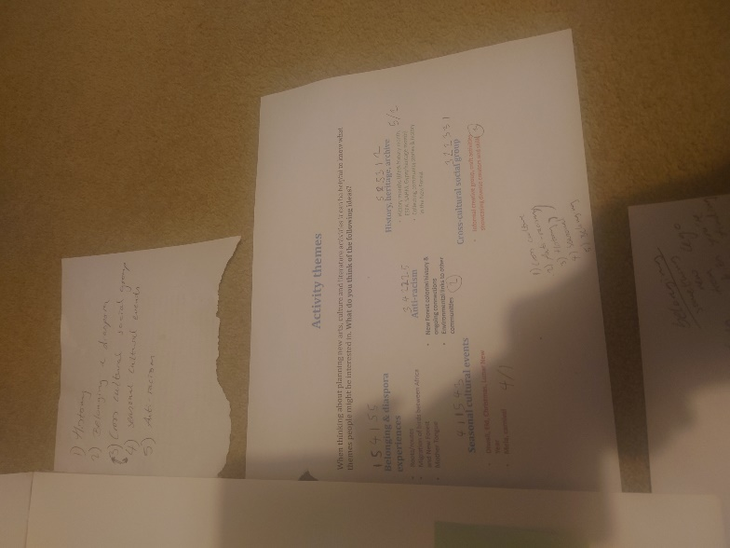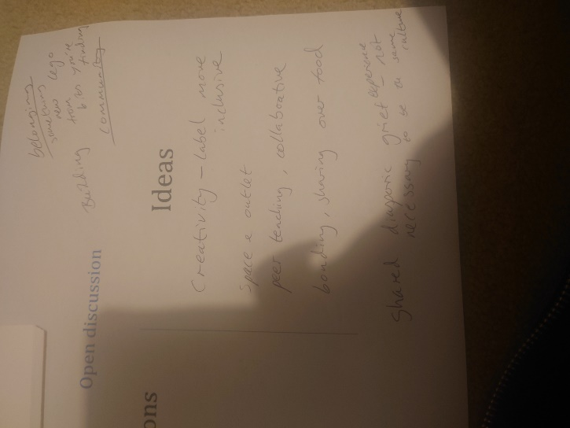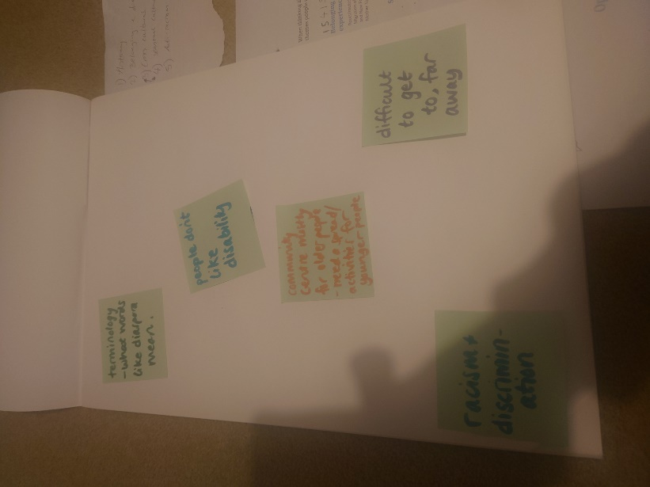

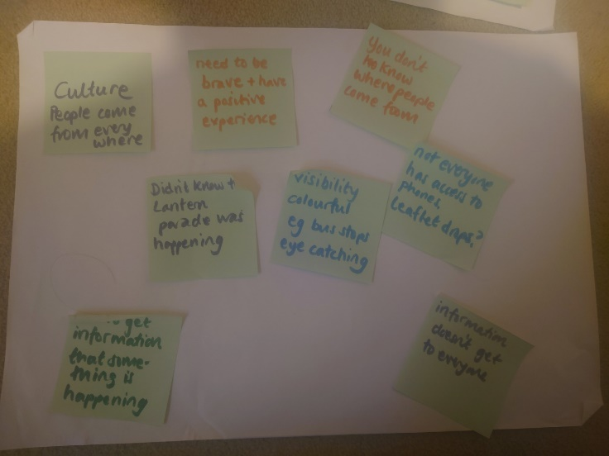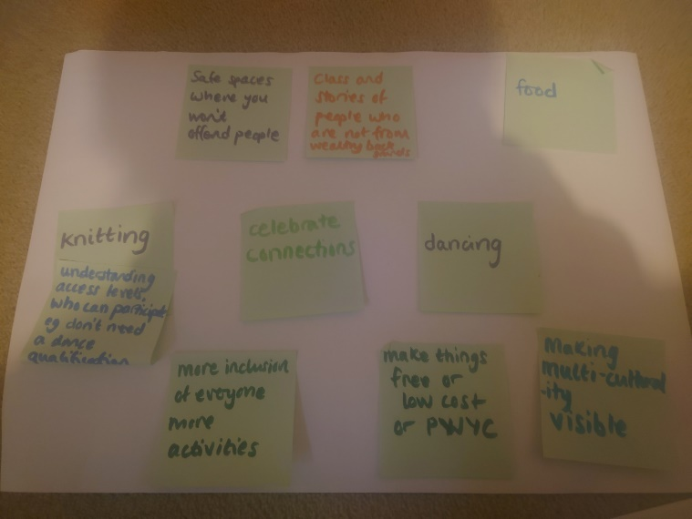

Online questionnaire results

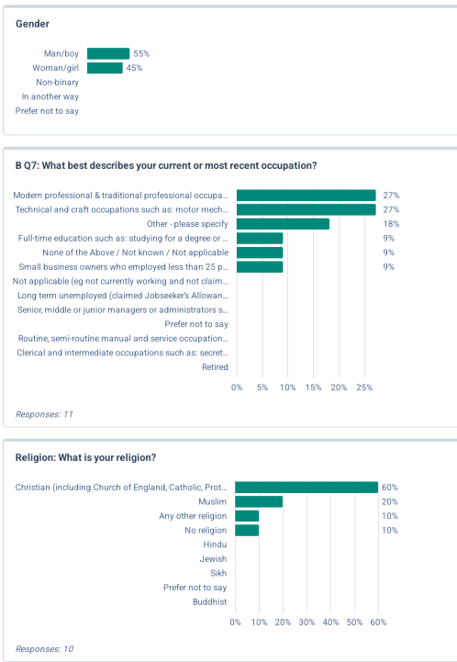 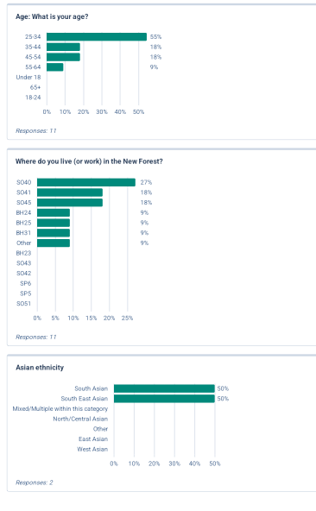

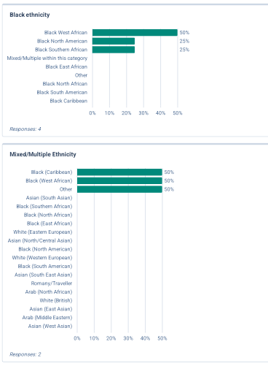 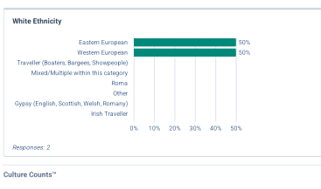

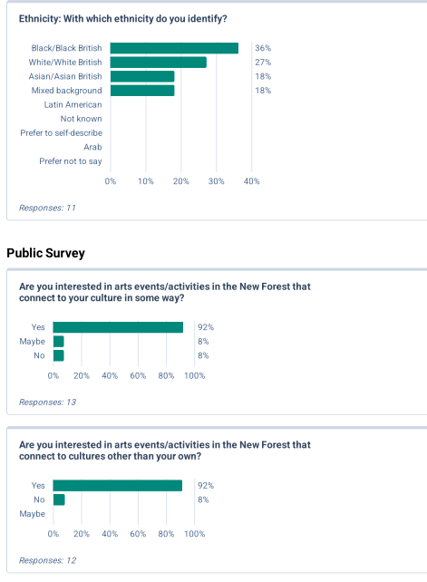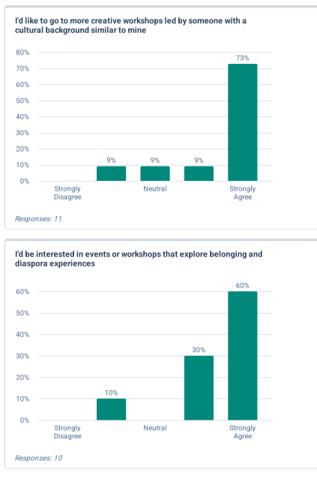

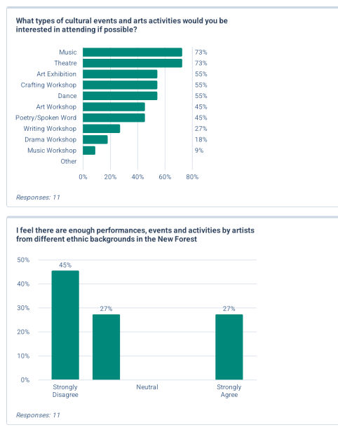 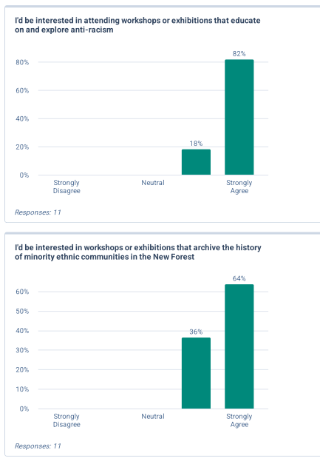

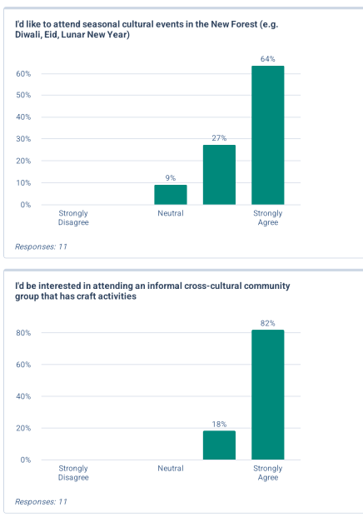 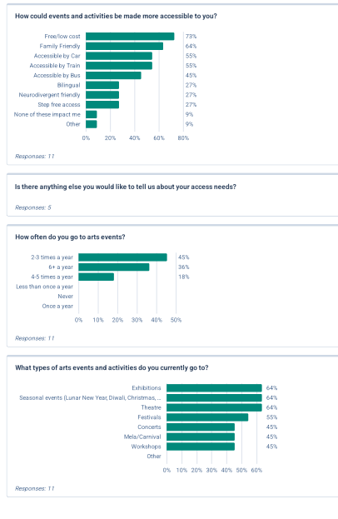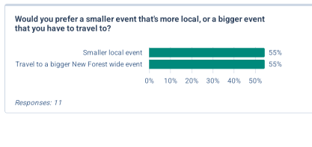 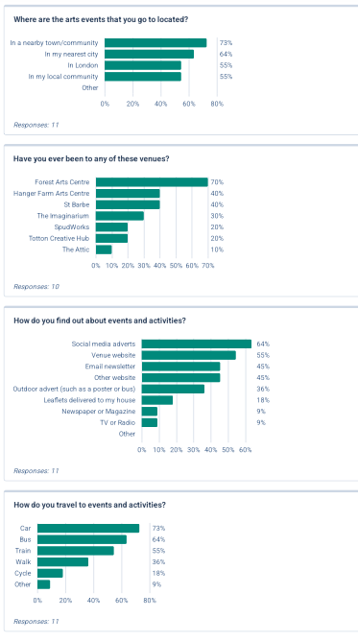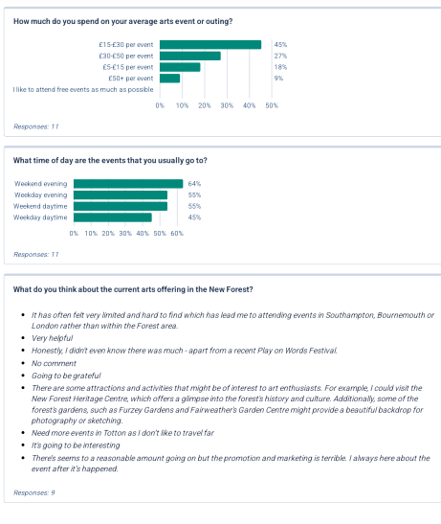

1. Office for National Statistics, ‘How life has changed in the New Forest’, published 2022, <<https://www.ons.gov.uk/visualisations/censuspopulationchange/E07000091/>>, [accessed Feb 2025].
2. Office for National Statistics, ‘How life has changed in the New Forest’, published 2022, <<https://www.ons.gov.uk/visualisations/censuspopulationchange/E07000091/>>, [accessed Feb 2025].
3. Office for National Statistics, ‘How life has changed in the New Forest’, published 2022, <<https://www.ons.gov.uk/visualisations/censusareachanges/E07000091/>>, [accessed Feb 2025].
4. ‘Hampshire Average Salary Comparison’, published 2023, <<https://www.plumplot.co.uk/Hampshire-salary-and-unemployment.html>>, [accessed Feb 2025].
5. Dr Dianna Smith, Dr Lauren Wilson, Laura Paddon ‘The cost of living in the New Forest’, page 4, published 2021, <<https://www.newforestcab.org.uk/wp-content/uploads/2022/01/Cost-of-Living-New-Forest-Report.pdf>>, [accessed Feb 2025].
6. Dr Dianna Smith, Dr Lauren Wilson, Laura Paddon ‘The cost of living in the New Forest’, page 5, published 2021, <<https://www.newforestcab.org.uk/wp-content/uploads/2022/01/Cost-of-Living-New-Forest-Report.pdf>>, [accessed Feb 2025].
7. ‘Learning about the New Forest National Park’, page 3, published 2007, <<https://www.newforestnpa.gov.uk/app/uploads/2018/01/aboutus1_keyfacts.pdf>>, [accessed Feb 2025].
8. ‘Learning about the New Forest National Park’, page 3, published 2007, <<https://www.newforestnpa.gov.uk/app/uploads/2018/01/aboutus1_keyfacts.pdf>>, [accessed Feb 2025].
9. City Population, ‘New Forest’, published 2023, <<https://citypopulation.de/en/uk/southeastengland/admin/E07000091__new_forest/>>, [accessed Feb 2025].
10. City Population, ‘New Forest’, published 2023, <<https://citypopulation.de/en/uk/southeastengland/admin/E07000091__new_forest/>>, [accessed Feb 2025].
11. ONS summary data suggests 0.7% of the GRT community currently lives in the New Forest, suggesting a population of more than 500. However, detailed census ethnicity data broken down by New Forest ward gives a total number of 604 which includes those who self-described as ‘White: Gypsy/Irish Traveler: 477’ ‘White: Roma: 115’, ‘White: Other Traveler: 8’, ‘Other ethnic group: Gypsy/Romany: 4’. [See Appendix]. Office for National Statistics, ‘Gypsy or Irish Traveller populations, England and Wales: Census 2021’ , published 2023, <<https://www.ons.gov.uk/peoplepopulationandcommunity/culturalidentity/ethnicity/articles/gypsyoririshtravellerpopulationsenglandandwales/census2021>>, [accessed Feb 2025].
12. ‘Data held on cohort sizes for children from Gypsy and Roma backgrounds (WROM) or Travellers of Irish Heritage (WIRT) generally present much lower numbers than local knowledge suggests is the true picture. Some Gypsy Roma Traveller (GRT) and Showmen families may choose to ascribe as White British (WBRI), White Irish (WIRI) or possibly White Other (WOTH) if they are of Eastern European Roma heritage. Furthermore, in some families there may be a blend of identities, a Showmen father with a Romany Gypsy mother, or a Romany Gypsy father with a mother whose ethnicity is unrelated to any Traveller heritage for example. Children in families like these examples might ascribe to various ethnic groups eg White Other (WOTH) or Mixed Other (MOTH). This can mean it is difficult for schools to accurately identify all their Gypsy Roma Traveller (GRT) and Showmen pupils.’ ‘Ethnic Minority and Traveller Achievement Service’, <<https://www.hants.gov.uk/educationandlearning/emtas/forparents/self-identification>>, [accessed Feb 2025].
13. Nomis, published 2025, <<https://www.nomisweb.co.uk/>>, [accessed Feb 2025].
14. This message is displayed on every spreadsheet downloaded via Nomis.
15. And this could well have been a piece of data swapped out in order to protect anonymity.
16. ESEA including, China, Korea, Japan, Laos, Vietnam, Thailand, Myanmar, Philippines, Malaysia, Singapore, and Taiwan ethnicities. SA including India, Bangladesh, Pakistan, Sri Lanka, Afghanistan, Nepal, Sikh, Punjabi, Sinhalese, Tamil, Kashmiri and Anglo-Indian ethnicities.
17. Our Lady of Lourdes Catholic Church, <<https://ourladyoflourdes.co.uk/>>, [accessed Feb 2025].
18. New Milton Community Centre, ‘Mahjong’, published 2021, <<https://newmiltoncommunity.org.uk/mah-jong.html>>, [accessed Feb 2025].
19. Anecdotal evidence of the influence of the military port on the Black community in Marchwood provided by African Activities, and Marchwood Junior School.
20. Marchwood Junior School, ‘Equality and Diversity Policy’, published 2025, <<https://www.marchwood-jun.hants.sch.uk/page/?title=Equality+%26amp%3B+Diversity&pid=49>>, [accessed Feb 2025].
21. Office for National Statistics, ‘Gypsy or Irish Traveller populations, England and Wales: Census 2021’ , published 2023, <<https://www.ons.gov.uk/peoplepopulationandcommunity/culturalidentity/ethnicity/articles/gypsyoririshtravellerpopulationsenglandandwales/census2021>>, [accessed Feb 2025].
22. “The earliest known document to record Gypsies in Hampshire is an entry in the Chawton, near Alton, Parish records in 1638.” New Forest Romany Gypsy Traveller, ‘The History of Gypsies in the New Forest’, published 2018, < [http://newforestromanygypsytraveller.co.uk/history.php.](%20http://newforestromanygypsytraveller.co.uk/history.php.)>, [accessed Feb 2025].
23. More information on the compound system and Gypsy Rehabilitation centres can be found in issue 75 of the Traveller’s Times. ‘Taking Ownership of Our Own Stories is More Crucial Than Ever’, *The Travellers Times*, issue 75 Autumn/Winter 2024, page 6.
24. For an overview of the history of the Romany Gypsies in the New Forest, including information on the locations of the historic camping sites, compounds, and rehabilitation centres please take a look at the New Forest Romany Gypsy Traveller website which has an extensive history section. New Forest Romany Gypsy Traveller, ‘The History of Gypsies in the New Forest’, published 2018, <<http://newforestromanygypsytraveller.co.uk/history.php.>>, [accessed Feb 2025].
25. First Steps New Forest, published 2025, <<http://firststepscharity.org/index.php>>, [accessed Feb 2025].
26. Dee Cooper, ‘Full House for New Forest Romany Exhibition’, *The Travellers Times*, Autumn/Winter Issue 75, page 7.
27. There is a chance that some respondents did not read the wording of this statement carefully as it is at odds with some of their other responses in the survey. It might be that anxiety around creating leading questions during the survey design meant that this question became less clear, especially to non-native English speakers and those with lower reading comprehension levels.
28. African Activities, <<https://africanactivities.org.uk/the-team/>>, [accessed Feb 2025].
29. I looked at the equality policies of 12 different schools in the district to get a feel for diversity activity levels. 7 of those schools had exactly the same Equality policy almost word for word, some of them with the templated wording appearing unedited and little to no evidence of actions around ethnic diversity. Some other school policies show evidence of curriculum reviews, and the broad aim to build more connections with different communities and have diverse visitors to the school. Marchwood Infant school recorded their work to achieve the bronze Hampshire EMTAS EAL Excellence award, and being part of the Hampshire Inclusion and Diversity Partnership.
30. “We believe passionately that those with the most potential are often the least able to pay for education, the least able to pull favours or access helpful networks, to work for free, or find shortcuts into paid creative and cultural work.” Arts Emergency, published 2024, <<https://www.arts-emergency.org/about-us>>, [accessed Feb 2025].
31. I’m paraphrasing here from a Show Racism the Red Card report. “Additionally all pupils have an ethnicity and a culture; if White British pupils are not made aware of this and understand their place within multicultural education they can become resentful of the celebration of cultures other than their own (Cockburn, 2007: 554).” Show Racism the Red Card, ‘The Barriers to Challenging Racism and Promoting Race Equality in England’s Schools’, page 8, published 2010, <<https://www.academia.edu/7221822/The_Barriers_to_Challenging_Racism_and_Promoting_Equality_in_Englands_Schools>>, [accessed Feb 2025].
32. Contact Culture in Common to read this report in full. Chris Rolls FRSA, ‘FORGING CULTURE RIGHTS IN THE NEW FOREST Activity, findings and recommendations from public engagement workshops carried out across the New Forest in June and July 2024 to explore local residents’ relationships to creativity, arts and culture and the implications for developing a cultural strategy for the New Forest’, published July 2024.
33. Chris Rolls, ‘Forging Culture Rights in the New Forest’, Page 8.
34. Chris Rolls, ‘Forging Culture Rights in the New Forest’, Page 8.
35. Aspace Arts, ‘Pitch Your Project: Black History Month’ published 2024,<<https://aspacearts.org.uk/events/pitch-your-project-black-history-month-2024>>, [accessed Feb 2025].
36. Arts Council England, ‘Guide to producing Equality Action Objectives and Plans for NPOs’, published 2017, <<https://www.artscouncil.org.uk/equality-action-plan-guidance>>, [accessed Feb 2025].
37. Chris Rolls, ‘Forging Culture Rights in the New Forest’, Page 11.
38. Chimamanda Ngozi Adichie, ‘The Danger of a Single Story’, published 2009, < <https://www.youtube.com/watch?v=D9Ihs241zeg>>, [accessed Feb 2025].